CREATE TABLE Accounts (
account_id NUMBER PRIMARY KEY,
customer_name VARCHAR2(100),
account_type VARCHAR2(20),
balance NUMBER(10,2)
);

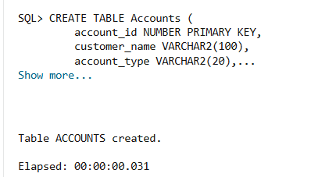
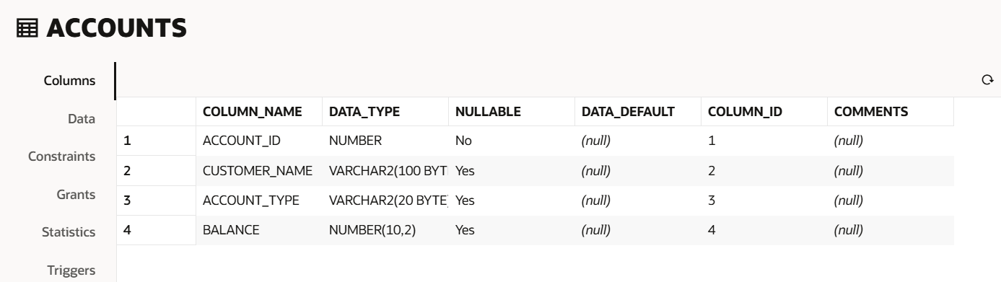

INSERT INTO Accounts VALUES (101, 'Rahul', 'Savings', 50000);
INSERT INTO Accounts VALUES (102, 'Priya', 'Savings', 25000);
INSERT INTO Accounts VALUES (103, 'Amit', 'Current', 40000);
COMMIT;


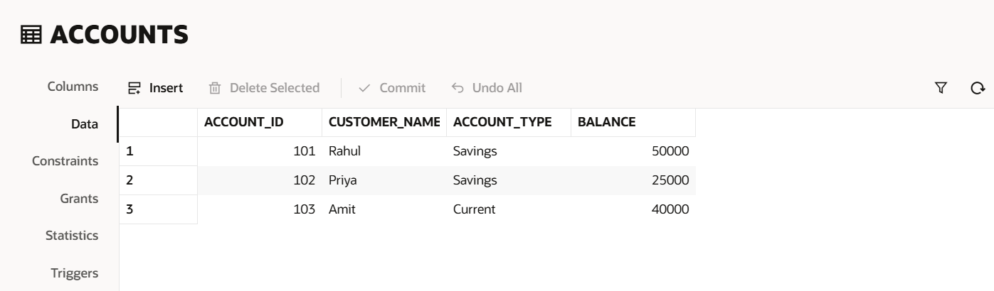

CREATE TABLE Employees (
emp_id NUMBER PRIMARY KEY,
emp_name VARCHAR2(100),
department VARCHAR2(50),
salary NUMBER(10,2)
);

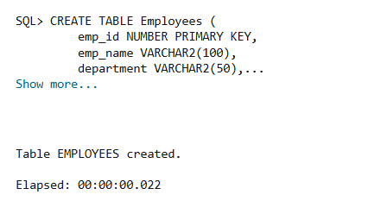

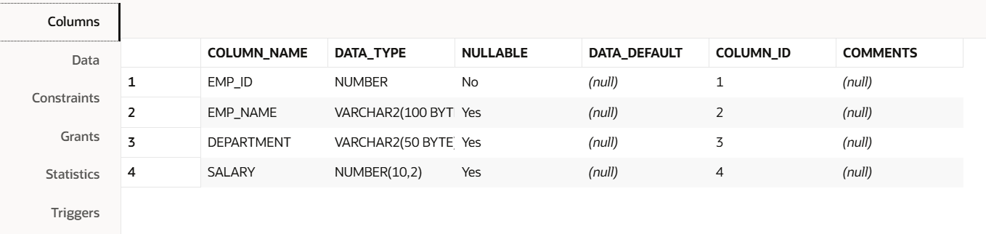

INSERT INTO Employees VALUES (1,'Ravi','HR',30000);
INSERT INTO Employees VALUES (2,'Sneha','IT',50000);
INSERT INTO Employees VALUES (3,'Kiran','IT',45000);
INSERT INTO Employees VALUES (4,'Anjali','Finance',40000);
COMMIT;

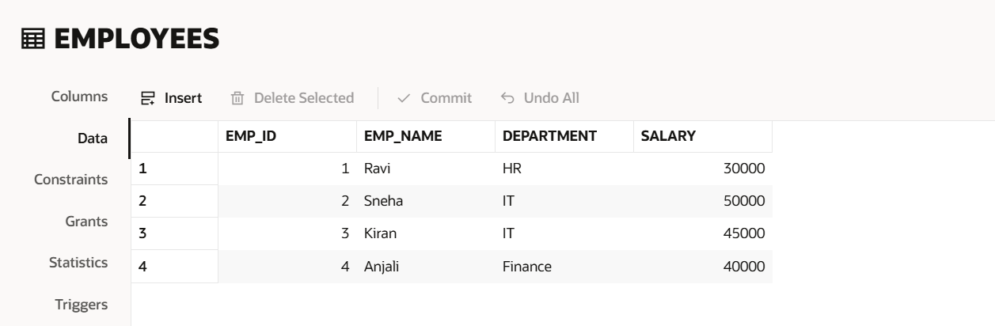

CREATE OR REPLACE PROCEDURE ProcessMonthlyInterest
AS
BEGIN
UPDATE Accounts
SET balance = balance + (balance * 0.01)
WHERE account_type = 'Savings';
COMMIT;
END;
/
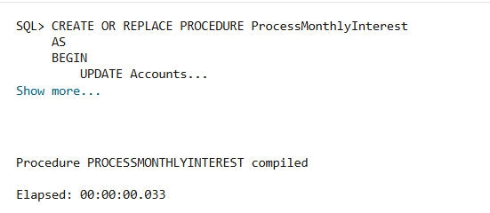
BEGIN
ProcessMonthlyInterest;
END;
/
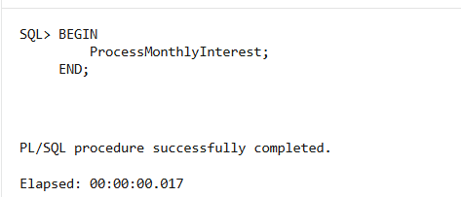

SELECT * FROM Accounts;
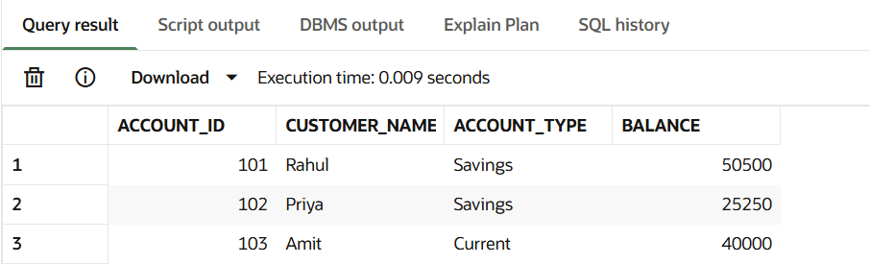

SCENARIO – 2
UPDATE EMPLOYEE BONUS

CREATE OR REPLACE PROCEDURE UpdateEmployeeBonus(
p_department IN VARCHAR2,
p_bonus IN NUMBER
)
AS
BEGIN
UPDATE Employees
SET salary = salary + (salary * p_bonus/100)
WHERE department = p_department;
COMMIT;
END;
/
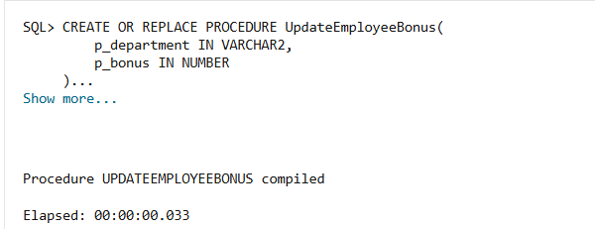

BEGIN
UpdateEmployeeBonus('IT',10);
END;
/

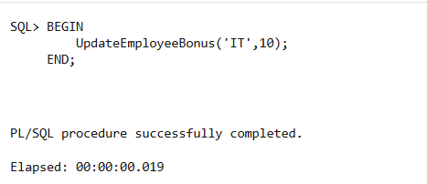

SELECT * FROM Employees;
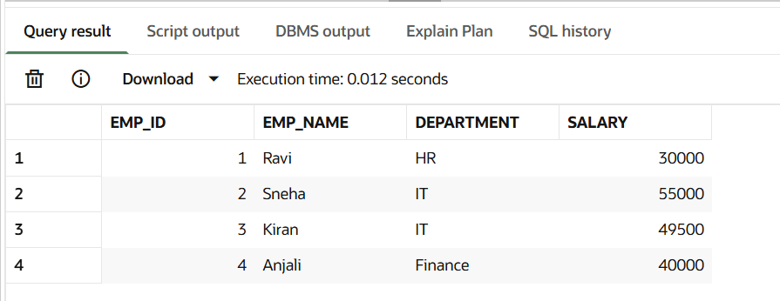
CREATE OR REPLACE PROCEDURE TransferFunds(
p_from_account IN NUMBER,
p_to_account IN NUMBER,
p_amount IN NUMBER
)
AS
v_balance NUMBER;
BEGIN
SELECT balance
INTO v_balance
FROM Accounts
WHERE account_id = p_from_account;
IF v_balance >= p_amount THEN
UPDATE Accounts
SET balance = balance - p_amount
WHERE account_id = p_from_account;
UPDATE Accounts
SET balance = balance + p_amount
WHERE account_id = p_to_account;
COMMIT;
DBMS_OUTPUT.PUT_LINE('Transfer Successful');
ELSE
DBMS_OUTPUT.PUT_LINE('Insufficient Balance');
END IF;
END;
/
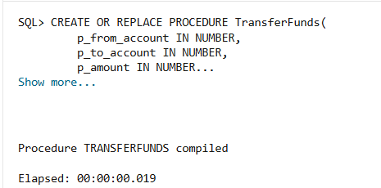
BEGIN
TransferFunds(101,102,5000);
END;
/
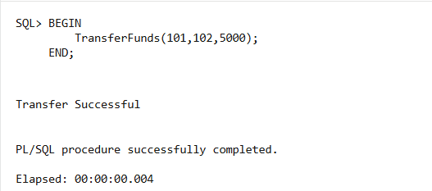

SELECT * FROM Accounts;
